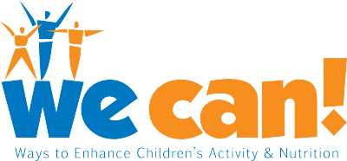

We Can! Grocery List Template

Use this template to ﬁll in your weekly grocery list. Some examples of GO and SLOW foods are included to help you. Print this sheet before every shopping trip and use it to help you pick healthier items for your family. Check out the Go, Slow, and Whoa Foods Chart on the We Can! Web site for more examples.

Fruits and Vegetables | Breads, Rice, Cereal, Pasta
GO: Apples | GO: Whole grain bread
GO: Spinach | GO:
GO: | GO:
GO: | GO:
GO: | GO:
GO: | GO:
GO: | GO:
GO: | GO:
GO: | GO:
GO: | SLOW: White rice
GO: | SLOW:
GO: | SLOW:
GO: | SLOW:
GO:
Meat, Poultry, Fish, Eggs, Beans and Nuts | Milk, Cheese, Yogurt
GO: Chicken breasts | GO: Low-fat or fat-free yogurt
GO: | GO: Fat-free milk
GO: | GO:
GO: | GO:
SLOW: Whole eggs | GO:
SLOW: | SLOW:
 | SLOW:

Grocery List Template

Packaged Foods | Fats, Oils, Sugar
GO: Canned pineapple in its own juice | SLOW: Olive oil
GO: Black beans | SLOW:
GO:
GO:
GO:
SLOW: Frozen pizza
SLOW:
SLOW: | Other (household items)
SLOW:

For more information about We Can! visit http://wecan.nhlbi.nih.gov or call 1-866-35-WECAN

We Can! is an effort of the the National Heart, Lung, and Blood Institute (NHLBI) in collaboration with the National Institute of Diabetes and Digestive and Kidney Diseases (NIDDK), the National Institute of Child Health and Human Development (NICHD) and the National Cancer Institute (NCI).

