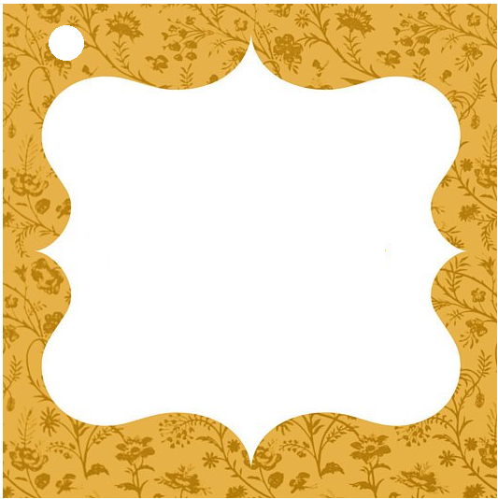
Heartily Wrapped with a Smile
To
From
Heartily Wrapped with a Smile
To
From

