  [Click here to add ingredients.]
  [Press the down arrow key to move to a new line.]
  [To delete tip text (such as this) just click it and type.]
  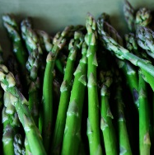
  [Date]
  (author)

[Recipe Name]
  [To print these cards two-sided, click File and then click Print.]
  [Select the setting that defaults to ‘Print One-Sided’ and then…]
  […choose a two-sided option. Available options vary by printer.]
  [Date]
  (author)

[Recipe Name]
  [Click here to add ingredients.]
  [Date]
  (author)

[Recipe Name]

[To easily try out different looks for these cards, on the Design tab…]
[…check out the Themes, Colors, and Fonts galleries.]

[Click here to add instructions.]

[Click here to add instructions.]

