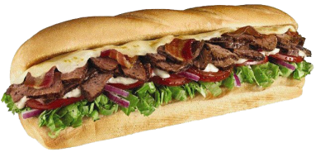

$1.00
OFF

Get $1 off any regularly priced
footlong sub or 50c off any
regularly priced 6-inch sub.

Offer expires 11/23/14

Not valid with any other offer. No cash value. Not for sale. Valid at participating SUBWAY restaurants. One coupon per customer per visit.
$1.00
OFF

Get $1 off any regularly priced
footlong sub or 50c off any
regularly priced 6-inch sub.

Offer expires 11/23/14

Not valid with any other offer. No cash value. Not for sale. Valid at participating SUBWAY restaurants. One coupon per customer per visit.
$1.00
OFF

Get $1 off any regularly priced
footlong sub or 50c off any
regularly priced 6-inch sub.

Offer expires 11/23/14

Not valid with any other offer. No cash value. Not for sale. Valid at participating SUBWAY restaurants. One coupon per customer per visit.
$1.00
OFF

Get $1 off any regularly priced
footlong sub or 50c off any
regularly priced 6-inch sub.

Offer expires 11/23/14

Not valid with any other offer. No cash value. Not for sale. Valid at participating SUBWAY restaurants. One coupon per customer per visit.

