
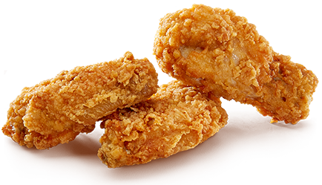
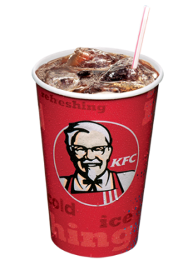
Bucket Sale
15 pieces of chicken
$17
For a limited time only
Promotion ends 11/23/14

Delivery charges extra. Premium charges for white meat where available for a limited time only. Delivery charges extra. Premium charges for white meat where available for a limited time only. Delivery charges extra. Premium charges for white meat where available for a limited time only.
Bucket Sale
Promotion ends 11/23/14

Delivery charges extra. Premium charges for white meat where available for a limited time only. Delivery charges extra. Premium charges for white meat where available for a limited time only. Delivery charges extra. Premium charges for white meat where available for a limited time only.
15 pieces of chicken
$17
For a limited time only

