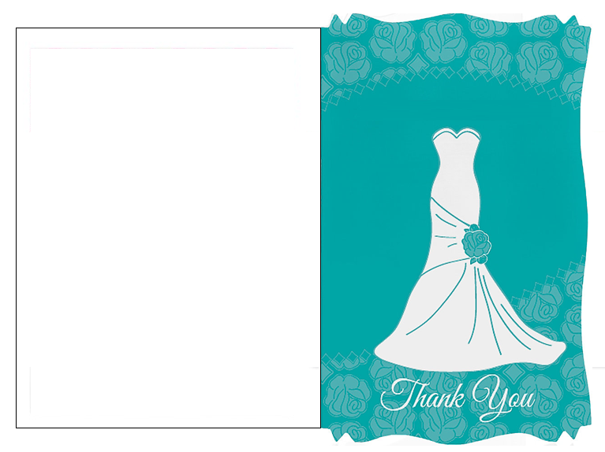
Inside text
You are one of my closest friends. You know how much you mean to me. With that said, nobody could have hosted my bridal shower as well as you did. You made the event more fun and special than I could have ever imaged. Thank you for being there for me

