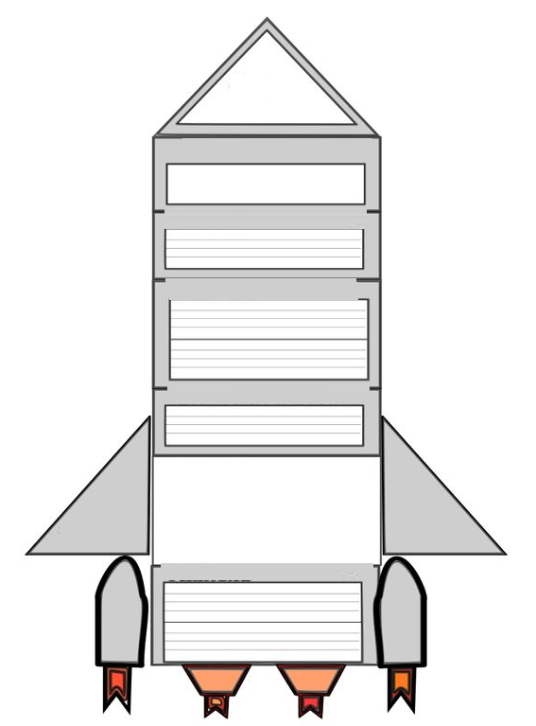

Lab Report Template

Conclusion

Chart/Data

Observsation/Result

Procedure

Hypothesis

Materials

Purpose