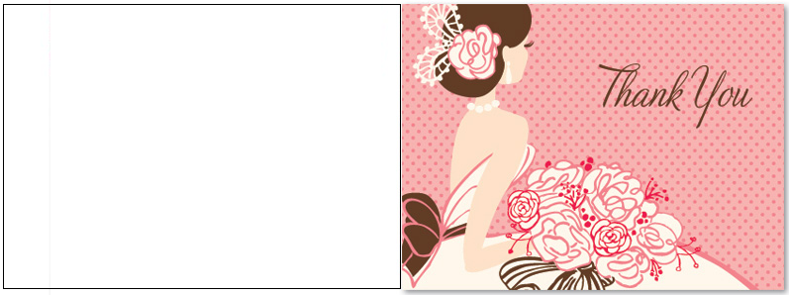
Inside text
Thank you so much for organizing my bridal shower. Everyone loved it especially the bridal shower games you invented. It was so sweet of you to take on such an enormous task

